Lab4

Andreas Hertin

2021-10-10

## (1)

Implementing GP Regression

## (1.1)

First task is implementing a function that derives the posterior distribution from given prior points and training data.

# Inspired by given code from José  
SquaredExpKernel <- function(x1,x2,sigmaF=1,l=3){  
 n1 <- length(x1)  
 n2 <- length(x2)  
 K <- matrix(NA,n1,n2)  
 for (i in 1:n2){  
 K[,i] <- sigmaF^2*exp(-0.5*( (x1-x2[i])/l)^2 )  
 }  
 return(K)  
}  
  
  
posteriorGP <- function(x, y, XStar, sigmaNoise, k, sigmaF=1, l=3){  
 n <- length(x)  
 K <- k(x, x, sigmaF, l)  
 L <- t(chol(K + sigmaNoise^2*diag(n)))  
 L_t <- t(L)  
 alpha <- solve(L_t, solve(L, y))  
 K_star <- k(x, XStar, sigmaF, l)  
 f_star <- t(K_star) %*% alpha  
   
 v <- solve(L, K_star)  
 K_star_star <- k(XStar, XStar, sigmaF, l)  
 cov <- K_star_star - t(v) %*% v  
 var <- diag(cov)  
   
 return(list(mean = f_star, var = var))  
   
}

## (1.2)

In this section the function is run with $σ_{f}=1$ and $l=0.3$ and a single point.

plotGP <- function(mean, var = NULL, interval, x, y, title){  
   
 if(!is.null(var)){  
   
 conf_int <- list(upper = mean + 1.96 * sqrt(var),  
 lower = mean - 1.96 * sqrt(var))  
   
 ylim <- c(min(conf_int$lower) - 2,  
 max(conf_int$upper) + 2)  
   
 plot(interval,   
 mean,   
 type = "l",   
 ylim = ylim,   
 col = "red",   
 main = title,   
 xlab = "x",   
 ylab= "Posterior mean",  
 lwd = 2)  
   
 lines(x = interval, y = conf_int$lower, col = "black", lwd = 2, lty = 2)  
 lines(x = interval, y = conf_int$upper, col = "black", lwd = 2, lty = 2)  
   
 } else {  
   
 ylim <- c(min(y) - 1,  
 max(y) + 1)  
   
 plot(interval,   
 mean,   
 type = "l",   
 main = title,   
 ylim = ylim,   
 col = "red",   
 xlab = "time",   
 ylab = "temp",  
 lwd = 2)  
   
 }  
   
 points(x,   
 y,   
 col = alpha("blue", 0.8),  
 pch = 4)  
}  
  
x <- 0.4  
y <- 0.719  
sigN <- 0.1  
sigF <- 1  
l <- 0.3  
x_star <- seq(-1, 1, length=100)  
  
posterior <- posteriorGP(x, y, x_star, sigN, SquaredExpKernel, sigF, l)  
  
plotGP(posterior$mean,  
 posterior$var,  
 x_star,  
 x,  
 y,  
 title = "Posterior mean with 95% probability bands")

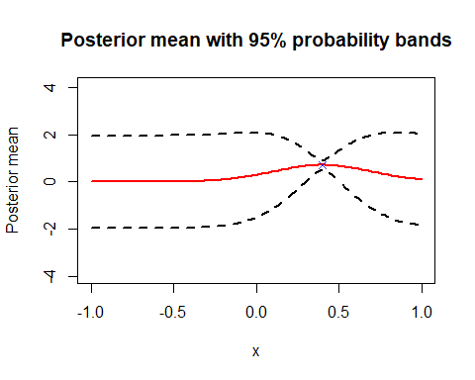

The probability bands is only close to the mean close to the given point. It is noit at the point because of assumed noise.

## (1.3)

Another point is added to see the effect on mean and their probability bands.

x <- c(0.4, -0.6)  
y <- c(0.719, -0.044)  
  
posterior <- posteriorGP(x, y, x_star, sigN, SquaredExpKernel, sigF, l)  
  
plotGP(posterior$mean,  
 posterior$var,   
 x_star,  
 x,  
 y,  
 title = "Posterior mean with 95% probability bands")

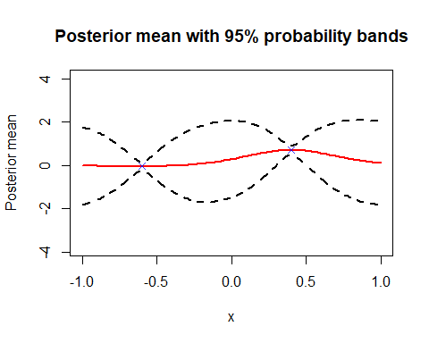

A similar response around the additional point as in **1.2**

## (1.4)

Even more points are added.

x <- c(-1.0, -0.6, -0.2, 0.4, 0.8)  
y <- c(0.768, -0.044, -0.940, 0.719, -0.664)  
  
posterior <- posteriorGP(x, y, x_star, sigN, SquaredExpKernel, sigF, l)  
  
plotGP(posterior$mean,   
 posterior$var,   
 x_star,  
 x,  
 y,  
 title = "Posterior mean with 95% probability bands")

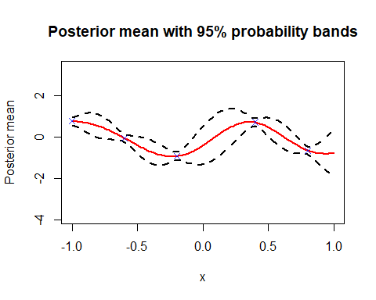

Points are now so close that the probability between them never reaches previous levels as they influence enough between eachother.

## (1.5)

sigF <- 1  
l <- 1  
  
posterior <- posteriorGP(x, y, x_star, sigN, SquaredExpKernel, sigF, l)  
  
plotGP(posterior$mean,  
 posterior$var,   
 x_star,  
 x,  
 y,  
 title = "Posterior mean with 95% probability bands")

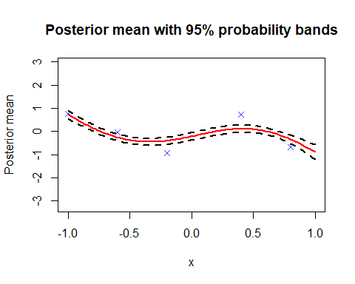

A quite drastic change can be observed when having $σ_{f}$ and $l$ both equal 1 in the kernel function when comparing the graphs from **1.4** and **1.5**. Having a higher $l$ means that correlation between two adjacent points and gives a smoother function. So graph in **1.5** is more smooth.

## (2)

GP regression on temperature data using kernlab

## (2.1)

A exponential kernel is created so that it can take in $σ_{f}$ and $l$

KernelFunction <- function(sigmaF, l) {  
 sqEx <- SquaredExpKernel <- function(x1, x2 = NULL){  
 n1 <- length(x1)  
 n2 <- length(x2)  
 K <- matrix(NA,n1,n2)  
 for (i in 1:n2){  
 K[,i] <- sigmaF^2*exp(-0.5*( (x1-x2[i])/l)^2 )  
 }  
 return(K)  
 }  
 class(sqEx) <- "kernel"  
 return(sqEx)  
}  
  
x <- c(1, 2, 3)  
x_star <- c(2, 3, 4)  
  
kernel <- KernelFunction(sigmaF = 1, l = 0.3)  
  
kernel_test <- kernel(1, 2)  
kernel_test

## [,1]  
## [1,] 0.00386592

cov_matrix <- kernelMatrix(x, x_star)  
cov_matrix

## An object of class "kernelMatrix"  
## [,1] [,2] [,3]  
## [1,] 1.000000e+00 0.00386592 2.233631e-10  
## [2,] 3.865920e-03 1.00000000 3.865920e-03  
## [3,] 2.233631e-10 0.00386592 1.000000e+00

## (2.2)

temps_csv <- read.csv("https://github.com/STIMALiU/AdvMLCourse/raw/master/GaussianProcess/Code/TempTullinge.csv", header=TRUE, sep=";")  
  
by_ <- 5  
  
time <- seq(1, 2190, by = by_)  
  
temps <- temps_csv$temp[time]  
  
fit <- lm(temps ~ time + I(time^2))  
  
sigN <- sd(fit$residuals)  
sigN

## [1] 8.176288

The estimate of the measurement noise ($σ_{n}$) is obtained by getting the standard deviation of the residuals when fitting a simple quadratic model to the data.

sigF <- 20  
l <- 0.2  
  
GPfit <- gausspr(x = time, y = temps, kernel = KernelFunction, kpar = list(sigmaF = sigF, l = l), var = sigN^2)  
  
GPmean <- predict(GPfit, time)  
  
plotGP(mean = GPmean, interval = time, x = time, y = temps, title = "Posterior mean")

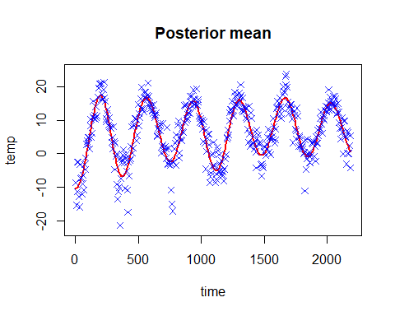

The posterior follows the data well. It does has a hard time coming close to extremes however.

## (2.3)

kernel <- KernelFunction(sigmaF = sigmaF, l = l)  
  
GPpred <- posteriorGP(scale(time), scale(temps), scale(time), sigN, SquaredExpKernel, sigmaF = sigF, l = l)  
  
sdTemps <- sd(temps)  
mnTemps <- mean(temps)  
  
meanPred <- GPpred$mean * sdTemps + mnTemps  
  
plotGP(mean = meanPred,  
 GPpred$var,   
 interval = time,   
 x = time,   
 y = temps,  
 title = "Time vs temp")

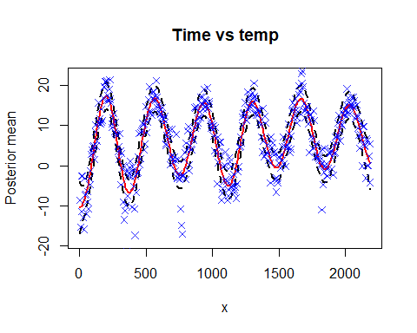

We can see that the bands incorporates more data points but fail to come close to the extremes (i.e at time ~750)

## (2.4)

days <- rep(seq(1, 365, by = by_), times = 6)  
  
GPdaily <- gausspr(days,   
 temps,   
 kernel = KernelFunction,   
 kpar = list(sigmaF = sigF, l = l),   
 var = sigN^2)  
  
dailyMean <- predict(GPdaily, days)  
  
plotGP(mean = GPmean,   
 var = GPpred$var,   
 interval = time,   
 x = time,  
 y = temps,   
 title = "Time vs temp")  
  
lines(x = time, y = dailyMean, col = "green", lwd = 2)  
  
legend("bottomright",   
 legend = c("Data points",   
 "Predicted mean (time)",   
 "Predicted mean (day)",   
 "95% probability bands"),  
 col = c("blue", "red", "black", "green"),  
 pch = c(4, NA, NA, NA),  
 lwd = c(NA, 2, 2, 2))

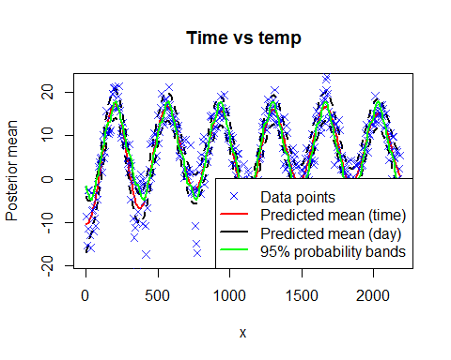

Some points have improved when using the day set compared to the all-times set but they are mostly similar.

## (2.5)

PeriodicKernel <- function(sigmaF, l1, l2, d){  
 val <- function(x, x_star){  
 dif <- abs(x - x_star)  
 out <- sigmaF^2*exp(-((2*sin(pi*dif)) / d) / l1^2) * exp(-0.5 * dif^2 / l2^2)  
 return(out)  
 }  
 class(val) <- "kernel"  
 return(val)  
}  
  
l1 <- 1  
l2 <- 10  
d <- 365 / sd(time)  
  
periodicKernel <- PeriodicKernel(sigF, l1, l2, d)  
GPper <- gausspr(time, temps, kernel = periodicKernel, var = sigN^2)  
perMean <- predict(GPper, time)  
plotGP(mean = perMean,  
 interval = time,  
 x = time,   
 y = temps,  
 title = "Time vs temp")  
  
lines(x = time, y = GPmean, col = "black", lwd = 2)  
lines(x = time, y = dailyMean, col = "green", lwd = 2)  
  
legend("bottomright",   
 legend = c("Data points",   
 "Periodic kernel",  
 "Predicted mean (time)",   
 "Predicted mean (day)"),  
 col = c("blue", "red", "black", "green"),  
 pch = c(4, NA, NA, NA),  
 lwd = c(NA, 2, 2, 2))

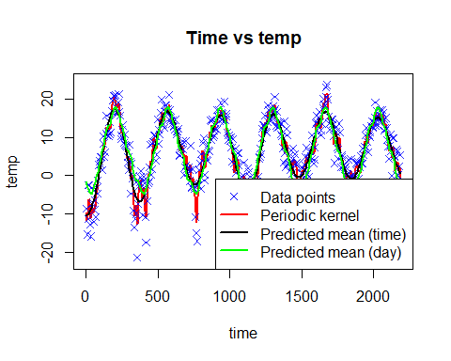 The periodic kernel is not as smooth as the other kernels but it does fit the data better. It captures more data further from the posterior mean.

## (3)

library(AtmRay)  
  
data <- read.csv("https://github.com/STIMALiU/AdvMLCourse/raw/master/GaussianProcess/Code/banknoteFraud.csv", header=FALSE, sep=",")  
names(data) <- c("varWave","skewWave","kurtWave","entropyWave","fraud")  
data[,5] <- as.factor(data[,5])  
set.seed(111)  
SelectTraining <- sample(1:dim(data)[1], size = 1000, replace = FALSE)  
  
trainData <- data[SelectTraining, ]  
testData <- data[-SelectTraining, ]

## (3.1)

fraudModel <- gausspr(fraud ~ varWave + skewWave, data = trainData)

## Using automatic sigma estimation (sigest) for RBF or laplace kernel

x1 <- seq(min(trainData$varWave), max(trainData$varWave), length=100)  
x2 <- seq(min(trainData$skewWave), max(trainData$skewWave), length=100)  
  
gridPoints <- meshgrid(x1, x2)  
gridPoints <- cbind(c(gridPoints$x), c(gridPoints$y))  
gridPoints <- data.frame(gridPoints)  
  
names(gridPoints) <- c("varWave", "skewWave")  
  
probPreds <- predict(fraudModel, gridPoints, type="probabilities")  
trainPreds <- predict(fraudModel, trainData)  
  
frauds <- which(trainData$fraud == 1)  
  
contour(x1,   
 x2,   
 matrix(probPreds[, 2], 100, byrow = TRUE),   
 20,   
 xlab = "varWave",   
 ylab = "skewWave",   
 main = 'Fraud probs')  
  
points(x = trainData$varWave[frauds],   
 y = trainData$skewWave[frauds],   
 col="blue")  
points(x = trainData$varWave[-frauds],   
 y = trainData$skewWave[-frauds],   
 col="red")

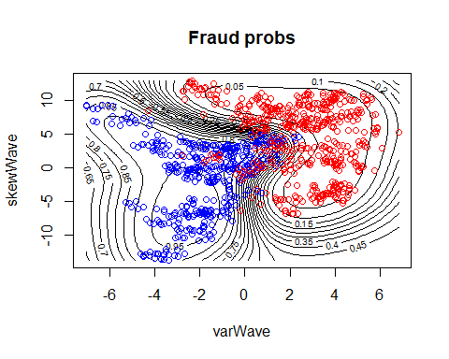

confMatrix = table(trainPreds, trainData$fraud)  
confMatrix

##   
## trainPreds 0 1  
## 0 503 18  
## 1 41 438

acc <- sum(diag(confMatrix)) / sum(confMatrix)  
acc

## [1] 0.941

The fraud points are red in the plot and the accuracy is 94.1%.

## (3.2)

testPreds <- predict(fraudModel, newdata = testData)  
  
confMatrix = table(testPreds, testData$fraud)  
confMatrix

##   
## testPreds 0 1  
## 0 199 9  
## 1 19 145

acc <- sum(diag(confMatrix)) / sum(confMatrix)  
acc

## [1] 0.9247312

The accuracy of the test data is high, but it naturally isn’t as good as that of the training data.

## (3.3)

fraudModel_2 <- gausspr(fraud ~., data = trainData)

## Using automatic sigma estimation (sigest) for RBF or laplace kernel

testPreds_2 <- predict(fraudModel_2, newdata = testData)  
  
confMatrix = table(testPreds_2, testData$fraud)  
confMatrix

##   
## testPreds_2 0 1  
## 0 216 0  
## 1 2 154

acc <- sum(diag(confMatrix)) / sum(confMatrix)  
acc

## [1] 0.9946237

Having more information leads to better accuracy since the new covariates only add additional information and do not remove any.